References
This document contains typical activity solutions and additional information referred to during the course.

Table of contents:
Activity 1: Terms and definitions 3
Additional definitions 4
Activity 2: MARIO against implementing an AIMS 5
Activity 3: Determining risks and opportunities 6
Activity 4: Clause 7: Support statements 9
Activity 5: Operation 11
Activity 6: Performance evaluation 11
Activity 7: Nonconformity and corrective action 12
Day 1 - References 15
Activity 8: ISO/IEC 42001 requirements 16
Activity 9: Holistic implementation process 19
Activity 10: Minimum documentation requirements 20
Activity 11: Baseline gap analysis 22
Activity 12: Create a Gantt chart 23
Activity 13: Understanding your context 23
Activity 14: Interested parties 23
Activity 15: Write a scope 23
Activity 16: Leadership and commitment 23
Activity 17: Create a policy 23
Activity 18: Risk and criteria 23
Activity 19: Identify and analyse artificial intelligence risks 23
Activity 20: Risk treatment 23
Activity 21: Create artificial intelligence objectives 23
Activity 22: Competency of individuals 24
Activity 23: Create AI system impact assessment process 25
Activity 24: Monitoring and measurement 26
Activity 25: Continual improvement process 26
Project management process and link to PDCA 28
Overall planning process 29
AIMS - Risk assessment process 30
AIMS - Risk treatment process 31
Activity 26: Leadership skills 32
Activity 27: Group ideas storming 32
Activity 28: Ishikawa/Fishbone 32
Activity 29: Kotter and psychological contracts 32
Activity 30: Skills and delegation 32
Activity 31: Motivation 32
Activity 32: Specimen exam paper 32

Activity 1: Terms and definitions
Term | Answer | Definition
1. Management system | H | - Information required to be controlled and maintained by an organization and the medium on which it is contained
2. Process | E | - Action to eliminate the cause of a nonconformity and to prevent recurrence
3. Performance | N | - Person or group of people that has its own functions with responsibilities, authorities and relationships to achieve its objectives
4. Competence | J | - Any information that (a) can be used to identify the PII principal to whom such information relates, or (b) is or might be directly or indirectly linked to a PII principal
5. AI system impact assessment | G | - Set of interrelated or interacting activities that uses or transforms inputs to deliver a result.
6. Control | K | - Intentions and direction of an organization as formally expressed by its top management
7. Corrective action |  | - Formal, documented process by which the impacts to individuals (and groups of individuals) and societies are identified, evaluating and addressed by an organization developing, providing or using products or services utilizing artificial intelligence
8. Risk |  | - Set of interrelated or interacting elements of an organization to establish policies and objectives, as well as processes to achieve those objectives
9. Documented information | A | - Preservation of confidentiality, integrity and availability of information
10. Requirement | L | - Ability to apply knowledge and skills to achieve intended results
11. Policy | F | - <Risk> measure that maintains and/or modifies risk
12. Organization | C | - Need or expectation that is stated, generally implied or obligatory
13. Audit | P | - Effect of uncertainty
14. Personally identifiable information (PII) | D | - Measurable result
15. Nonconformity | O | O. Non-fulfillment of a requirement
16. Information security | I | - Systematic and independent process for obtaining evidence and evaluating it objectively to determine the extent to which the audit criteria are fulfilled

Additional definitions
- Interested party (preferred term) / stakeholder (admitted term) - person or organization that can affect, be affected by, or perceive itself to be affected by a decision or activity
- Process – set of interrelated or interacting activities that use inputs to deliver an intended result
- Outsource – make an arrangement where an external organization performs part of an organization’s functions or process
- Top management - person or group of people who directs and controls an organization at the highest level
- Objective - result to be achieved
- Continual improvement – recurring activity to enhance performance
- Correction – action to eliminate a detected nonconformity
- Effectiveness – extent to which planned activities are realized and planned results achieved
- Conformity - fulfilment of a requirement
- Measurement – process to determine a value
- Monitoring – determining the status of a system, a process, a product, a service or an activity
- Statutory requirement – obligatory requirement specified by a legislative body
- Regulatory requirement – obligatory requirement specified by an authority mandated by a legislative body
- Governing body - person or group of people who are accountable for the performance and conformance of the organization

Activity 2: MARIO against implementing an AIMS

Managed (3)

Resources (3)
Output (1)
Implement ISO/IEC 42001
Input (3)

Activity 3: Determining risks and opportunities
# | Issues (internal) | Expected results | Uncertainty | Risk H/M/L  (Effect) | Opportunities
1 | Lack of technical knowledge in the organization | There is enough knowledge to deal with changes to technology and deal with new AIMS threats | Potential to not keep up with our competitors and increased risk of a security incident | H | Opportunity to provide training to existing personnel or to recruit AIMS quality/regulatory role
2 | Inadequate AI model validation practices within the organization
3 | AI model interpretability and transparency concerns
# | Issues (external) | Expected results | Uncertainty | Risk (-ve) H/M/L  (Effect) | Opportunities
4 | Impact of data loss from environmental disasters
5 | Evolution of adversarial AI attacks
6 | Rapid advancements in AI algorithms and architectures
# | IP requirements | Expected results | Uncertainty | Risk (-ve) H/M/L  (Effect) | Opportunities
7 | Executive Board
8 | AI Regulators
9 | AI Customers/End-users

*Risk (Effect) could be purely a description rather than a H, M, L.
If H, M, L is used then a description as to what constitutes this would be necessary.
A simple combination of likelihood and consequence is equally valid, to derive risk.
Your tutor will review any opportunities (not deriving from a negative effect) that you may have identified, and its associated risk.

Activity 4: Clause 7: Support statements
Number | ISO/IEC 42001 Clause Reference | Statement | T / F
1 | 7.1 | Shall provide resources for continual improvement of the AIMS
2 | 7.1 | Resources can encompass financial, technical, and human assets
3 | 7.2 | Where applicable, evaluate the efficacy of AI-centric training
4 | 7.2 | Maintain documented proof of AI competence
5 | 7.2 | Acquiring AI competence doesn't always necessitate formal training
6 | 7.2 | Define required AI expertise for all relevant roles
7 | 7.2 | Training is the only solution to ensure AI competence
8 | 7.3 | Individuals influenced by the AIMS should understand their impact on its efficacy
9 | 7.3 | Every individual should be conversant with the AI policy
10 | 7.3 | Personnel interacting with AIMS should understand non-compliance implications
11 | 7.4 | Ascertain the need for internal and external AI-centric communications
12 | 7.4 | A well-defined AI communication process is essential
13 | 7.4 | Everyone should receive all AI-related communications
14 | 7.5.1 | The nature of documented information is universal for all AI implementations
15 | 7.5.2 | Use suitable language and visuals for AI documented information
16 | 7.5.2 | Every AI-related automatically undergoes review and approval
17 | 7.5.3 | AI-documented info mandated by the AIMS must always be shielded
18 | 7.5.3 | Document access could solely mean viewing permissions
19 | 7.5.3 | All AI-related documented info necessitates control
20 | 7.5.3 | AI-specific documents should always be universally accessible
21 | 7.5.3 | Always retain documents, but ensure efficient document management systems
22 | 7.5.3 | Externally sourced AI documentation should always be managed and cataloged

Activity 5: Operation
Please see the electronic file, Risk assessment and SoA document risk register tab, for examples.

Activity 6: Performance evaluation
Risk: | LSAI 01_23
 | Monitor/measurement 1 | Monitor/measurement 2
Control 1 –

Control 2 –

Control 3 –

Activity 7: Nonconformity and corrective action

- NC 1 – Allocation of AI responsibilities

- Finding: In the examination of AI system deployment processes, it was observed that the AI Project Lead holds authority over both AI model parameter configuration and final deployment authorization. This dual authority contradicts best AI engineering practices and regulatory stipulations, jeopardizing unbiased model validation.
- Objective evidences:
- AI Deployment Protocol Document: Section 3.2 delineates the roles and responsibilities, explicitly vesting both configuration and deployment powers with the AI Project Lead.
- AI Model Deployment Logs: Records from 20th January 2023 to 15th April 2023 show multiple instances where the AI Project Lead signed off on both parameter configuration changes and subsequent model deployments.
- Internal Communications: Emails dated between February and March 2023 where the AI Project Lead directs the team on model parameter adjustments and later approves the deployment in the same thread.
- Interview Transcripts: During the audit, three team members independently confirmed that the AI Project Lead often holds dual authority during the model development cycle, particularly in the final stages leading to deployment.
- Control (B.10.2) Allocating responsibilities: Responsibilities for AI systems shall be clearly delineated.
- Company Response: Accepted. The duties of defining AI model parameters and the sign-off for deployment will be segregated. A wider review of roles and responsibilities within the AI team will be undertaken to ensure that this is not an isolated issue.
- Expected response:

- NC 2 – Data provenance

- Finding: Upon a meticulous audit of the AI data ingestion and lineage logs spanning the previous fiscal year, it was discerned that three critical projects, identified as AI-ProjectX, AI-ProjectY, and AI-ProjectZ, lacked the requisite metadata documentation that traces back to their primal data sources. This omission has raised concerns regarding the provenance and ethical sourcing of the data, potentially infringing on the stipulated data integrity and traceability requirements outlined in Section 7 of the AI Management Standards.
- Objective evidences:
- AI-ProjectX Data Lineage Log:
Log Entry Date: 12-03-2022.
Missing Field: Original DataSource URL.
Ingestion Batch ID: 3421B.
- AI-ProjectY Metadata Documentation:
Data Profiling Report Date: 23-04-2022.
Unlinked Record Count: 450,000 (No associated source identifier).
File Reference: Y_DataProfile_Report_23042022.pdf.
- AI-ProjectZ Data Integrity Check:
Audit Date: 09-06-2022.
Identified Gaps: Lack of Digital Signatures on 20% of data chunks.
Associated System Log: Z_DigiSignature_AuditLog_09062022.log.
- Control (B.7.5) Data provenance: The origin of the data and its chain of custody shall be documented and verifiable.
- Company response: Accepted. A procedure will be established to maintain clear records of all data sources, ensuring their origin and chain of custody is ethically sound and transparent.
- Expected response:

- NC 3 – Transparency in AI decision-making

- Finding: During the audit of AI models designated M-235, M-422, and M-489 in active deployment, it was identified that the decision-making algorithms employed in these models lack both transparency and interpretability. This inconsistency directly contravenes Section 4.3(a) of the company's AI Transparency Mandate.
- Objective evidences:
- Technical Logs: AI Model M-235 exhibited a 35% rate of outputs without accompanying justification metadata during a 100-sample test run on 02/15/2023.
- User feedback report: In the quarterly user assessment survey, 60% of data scientists reported difficulties in understanding the decision rationale behind AI Model M-422's predictions.
- Algorithm Analysis: A peer review conducted on the source code of Model M-489 found that its layer weights and activation functions were obscured, with no available documentation to elucidate its decision pathways.
- Internal Audit Note: During the biannual AI model audit, it was found that all three models (M-235, M-422, and M-489) lacked a standardized "explainability layer" or equivalent mechanism for ensuring transparent AI operations, as specified in the AI Transparency Mandate guidelines.
- Control (B.8.3) Understandability of provided information: Information about the AI system’s design, development, and deployment should be understandable to intended users.
- Company response: Accepted. The AI models identified will be reviewed to enhance their transparency and ensure decision-making processes can be explained and understood.
- Expected response:

Day 1 - References
Lean Six Sigma references

1. Belt structure
In some organizations, when using the Lean Six Sigma approach, a leadership and role structure is introduced based on the martial arts. For example, a Green Belt may be a part-time leader of improvement projects whose primary role is functional, whereas a Black Belt may be a full-time specialist in improvement.

2. DMAIC process
The DMAIC process, used in Lean Six Sigma as a project and improvement methodology, is analogous to the Plan, Do, Check, Act process popularized by Deming which many people involved in quality management and QMS systems will already be familiar with. DMAIC stands for Define, Measure, Analyse, Improve, Control.

3. The principles of lean
- Define value from the customer’s perspective
- Identify the value stream (process activities) needed to take a product or service from customer request to completed delivery
- Ensure product or service based activity flows through the value stream without delays
- Use pull systems, so that the product or a service is provided only when the customer wants it
- Strive continuously to eliminate all forms of waste (non-value adding activity) from the processes involved

4. The principles of Six Sigma
- Gather information to understand the customer’s voice
- Convert this understanding to targets and specifications for process performance
- Use data to analyse current state process variability, and relate this to the customer driven targets and specifications that are now established
- Understand the factors that are the root causes of process variability and work to eliminate or reduce their impact for an improved state process
- Establish long term control procedures to maintain the gains

5. Lean Six Sigma standards
For those interested in the standards associated with Lean Six Sigma there are a number available, which can help guide the practitioners’ organization:
- ISO13053 Part 1 Quantitative methods in process improvement – Six Sigma – DMAIC Methodology
- ISO13053 Part 2 Quantitative methods in process improvement – Six Sigma – Tools and Techniques
- ISO17258 Statistical methods – Six Sigma – Basic criteria underlying benchmarking for Six Sigma in organizations
- ISO18404 Quantitative methods in process improvement – Six Sigma – Competencies for key personnel and their organizations in relation to Six Sigma and Lean implementation

Activity 8: ISO/IEC 42001 requirements
ISO/IEC 42001 Clause Reference | Statement 1  (True) | Statement 2  (True) | Statement 3  (False)
4.1
4.2
4.3
4.4
5.1
5.2
5.3
6.1
6.2
6.3
7.1
7.2
7.3
7.4
7.5
8.1
8.2
8.3
8.4
9.1
9.2
9.3
10.1
10.2

Activity 9: Holistic implementation process

Activity 10: Minimum documentation requirements

ISO/IEC 42001 clause: | Documented requirements
4.1
4.2
4.3
4.4
5.1
5.2
5.3
6.1.1
6.1.2
6.1.3
6.1.4
6.2
6.3
7.1
7.2
7.3
7.4
7.5.1
7.5.2
7.5.3
8.1
8.2
8.3
8.4
9.1
9.2
9.3
10.1
10.2

Activity 11: Baseline gap analysis

Delegate score: 0 – 10
There is every chance that their operation is running at higher levels of risk. They have below average controls on their processes and their artificial intelligence system effects. They could be exposed to unacceptably high numbers of breaches and undesired behaviors (e.g. bias, non-robustness, high amount of cybersecurity vulnerabilities etc.). This could lead to significant damage to their brand and reputation. If they are a service provider, they know little about their indirect effects, and could be denying themselves an improved marketing position.
Delegate Score: 11 – 30
They may well have identified some elements within their organization that have the capacity to help them manage AI-systems effects. They may even have undertaken some AIMS related initiatives (such as AIMS training and awareness), but as yet they are content to cope with problems as they appear, rather than choose a more proactive approach. It may be that, they have no sense that issues in a life cycle of AI-system(s) are central to the continued sustainability of their company and as long as their current arrangements continue to keep them within compliance of the law on a day-to-day basis, they see no reason to engage in any activity that changes the situation. As a result, they are missing out on business improvement and extra profits.
Delegate Score: 31 – 60
They have already begun to identify those issues in a life cycle of AI-system(s) that are pertinent to their company and its stakeholders. They have the building blocks of an artificial intelligence management system in place, and probably have some good in-house technical expertise currently focused on other work. They may have controlled activities on site, with extremely good technology that ensures incidents in life cycles of AI-system(s) are kept to a minimum.
Delegate Score: 61 – 80
They already have a fledgling AIMS in place. It may be that it has not been very long in existence and is still generating its first useful information. However, they have come a substantial way towards reaching their target and they are well on the way to being ready for certification or verification by an outside body.
Delegate Score: 81 – 108
It is unclear what their objective is in attending this workshop. Their score indicates that they are already in amongst the foremost proponents of AIMS, and would gain little from this training, unless they are sitting with many of their suppliers whom they wish to encourage down a similar path.

Activity 12: Create a Gantt chart

Activity 13: Understanding your context

- Organization’s purpose/intended outcome(s) of its AIMS?
- Internal issues relevant to question 1)?

- External issues relevant to question 1)?

- Processes, associated activities and functions that can impact artificial intelligence?
- Interfaces and dependencies between activities performed by the organization?
- Interfaces and dependencies between activities performed by other organizations?

Activity 14: Interested parties

Your organization
Citizens  Customers  Distributors  Shareholders  Investors  Owners  Insurers  Government  Regulators  Recovery service suppliers |  | Management  - Top management  - Those accountable for AIMS policy and implementation  Those who implement and maintain the AIMS  - Those who maintain AIMS and risk procedures  Other staff  Contractors |  | Media  Commentators  Trade groups  Neighbours  Pressure groups  Emergency services  Other response agencies  Transport services  Staff dependents

Activity 15: Write a scope

Activity 16: Leadership and commitment

Activity 17: Create a policy

Activity 18: Risk and criteria

Activity 19: Identify and analyse artificial intelligence risks

NO. | Risk details | Consequence | Likelihood | Risk score
1
2
3
4
5
6
7
8
9
10

Activity 20: Risk treatment

NO. | Risk treatment options | Controls selected | Source?
1
2
3
4
5
6
7
8
9
10

Activity 21: Create artificial intelligence objectives

Activity 22: Competency of individuals
Role | Competency
AI system developer
AIMS Manager
AIMS internal auditor

Activity 23: Create AI system impact assessment process
Process step |  |  | Element
Initiation |  |  | A. Assess the likelihood and severity of identified impacts, considering factors such as the AI system's complexity, deployment context, and stakeholder perspectives
 |  |  | B. Define the scope of the assessment, specifying the AI system(s) under evaluation, their intended use, and potential impact areas to be assessed
Planning |  |  | C. Establish mechanisms for ongoing monitoring and evaluation of the AI system's impacts, both during development and deployment phases
 |  |  | D. Foster dialogue and engagement with stakeholders to build trust, address concerns, and promote responsible AI development and use
Stakeholder engagement |  |  | E. Identify the need for an AI system impact assessment, either as part of regulatory requirements, corporate governance, or ethical considerations
 |  |  | F. Develop strategies to mitigate or manage identified risks and negative impacts, while maximizing the positive contributions of the AI system
Impact identification |  |  | G. Identify and engage relevant stakeholders, including developers, users, affected communities, regulatory authorities, and subject matter experts
 |  |  | H. Prepare a comprehensive report summarizing the assessment process, key findings, and proposed actions for stakeholders and decision-makers
Risk assessment |  |  | I. Conduct a comprehensive analysis to identify potential impacts of the AI system across various dimensions, such as social, economic, environmental, ethical, legal, and technical
 |  |  | J. Continuously review and update impact assessment methodologies and practices to reflect evolving technologies, regulatory frameworks, and societal expectations
Ethical analysis |  |  | K. Formulate a clear objective for the assessment, outlining the scope, stakeholders involved, and desired outcomes
 |  |  | L. Evaluate the AI system's alignment with ethical principles and values, such as fairness, transparency, accountability, and respect for human rights
Process step |  | Element
Impact mitigation strategies |  | M. Collect feedback from stakeholders and assess the effectiveness of mitigation strategies in addressing identified risks and concerns
 |  | N. Explore technical, organizational, regulatory, and societal interventions to address ethical, social, and environmental concerns
Monitoring and evaluation |  | O. Conduct stakeholder consultations to gather diverse perspectives, concerns, and priorities related to the AI system and its potential impacts
 |  | P. Document the findings of the impact assessment, including the methodology used, data sources, analysis results, and recommendations
Documentation and reporting |  | Q. Prioritize impacts based on their significance and urgency for mitigation or management
 |  | R. Establish a multidisciplinary team with expertise in AI, ethics, law, sociology, and other relevant fields
Communication and transparency |  | S. Communicate the results of the impact assessment to relevant stakeholders in a transparent and accessible manner
 |  | T. Identify potential ethical dilemmas or biases in the design, development, or use of the AI system
Improvement |  | U. Incorporate lessons learned from the impact assessment into future AI development and deployment processes
 |  | V. Consider both positive and negative impacts, as well as direct and indirect consequences

Activity 24: Monitoring and measurement

Part 1: Using your copy of ISO/IEC 42001, identify what would need monitoring, measuring, analysing and evaluating within the Standard. Identify these on a flipchart or in the materials provided
Part 2: Considering one risk treatment you selected from Activity 20, identify how that control could be monitored and how you could measure its effectiveness.

Activity 25: Continual improvement process

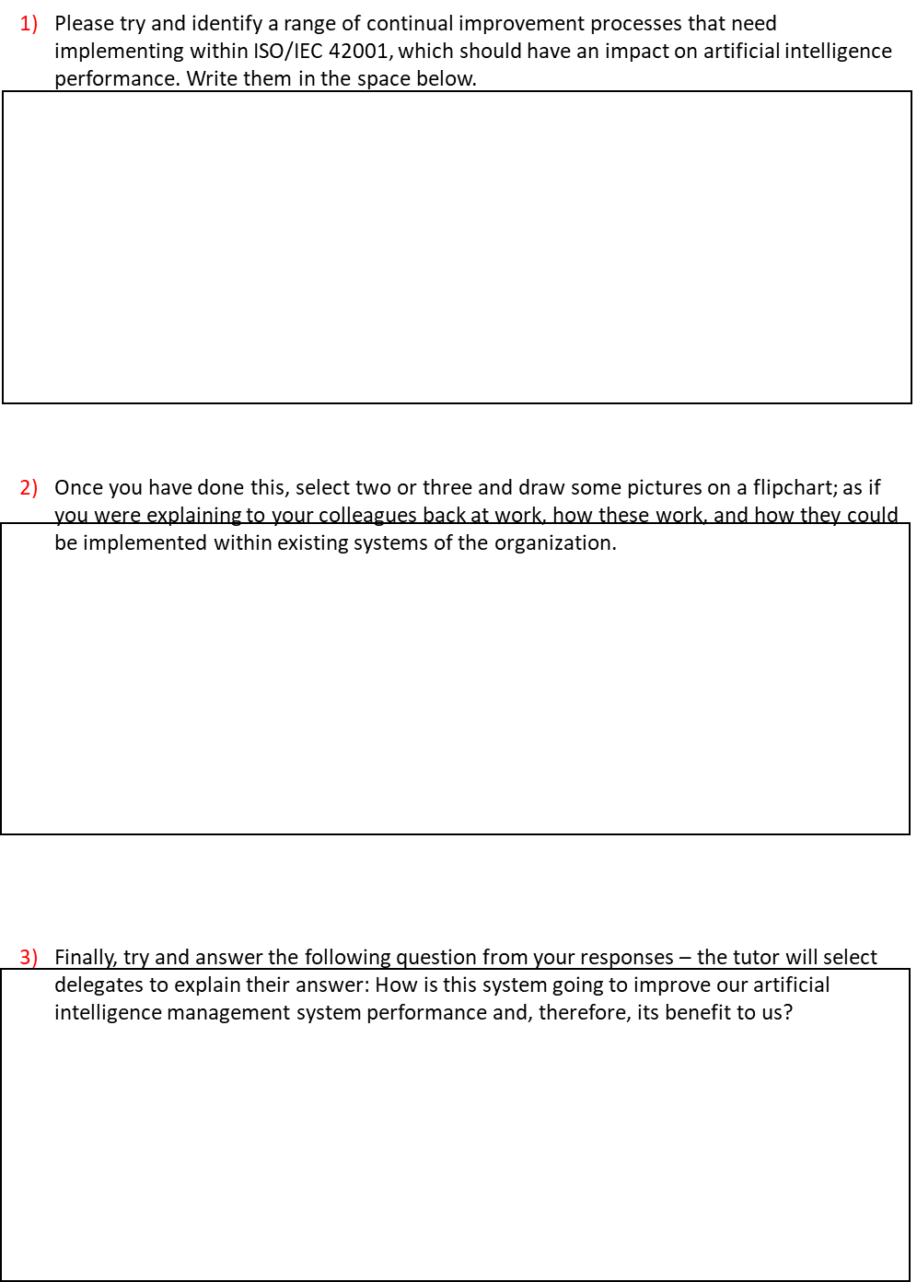

Activity 26: Leadership skills

Activity 27: Group ideas storming

Activity 28: Ishikawa/Fishbone

Activity 29: Kotter and psychological contracts

Activity 30: Skills and delegation

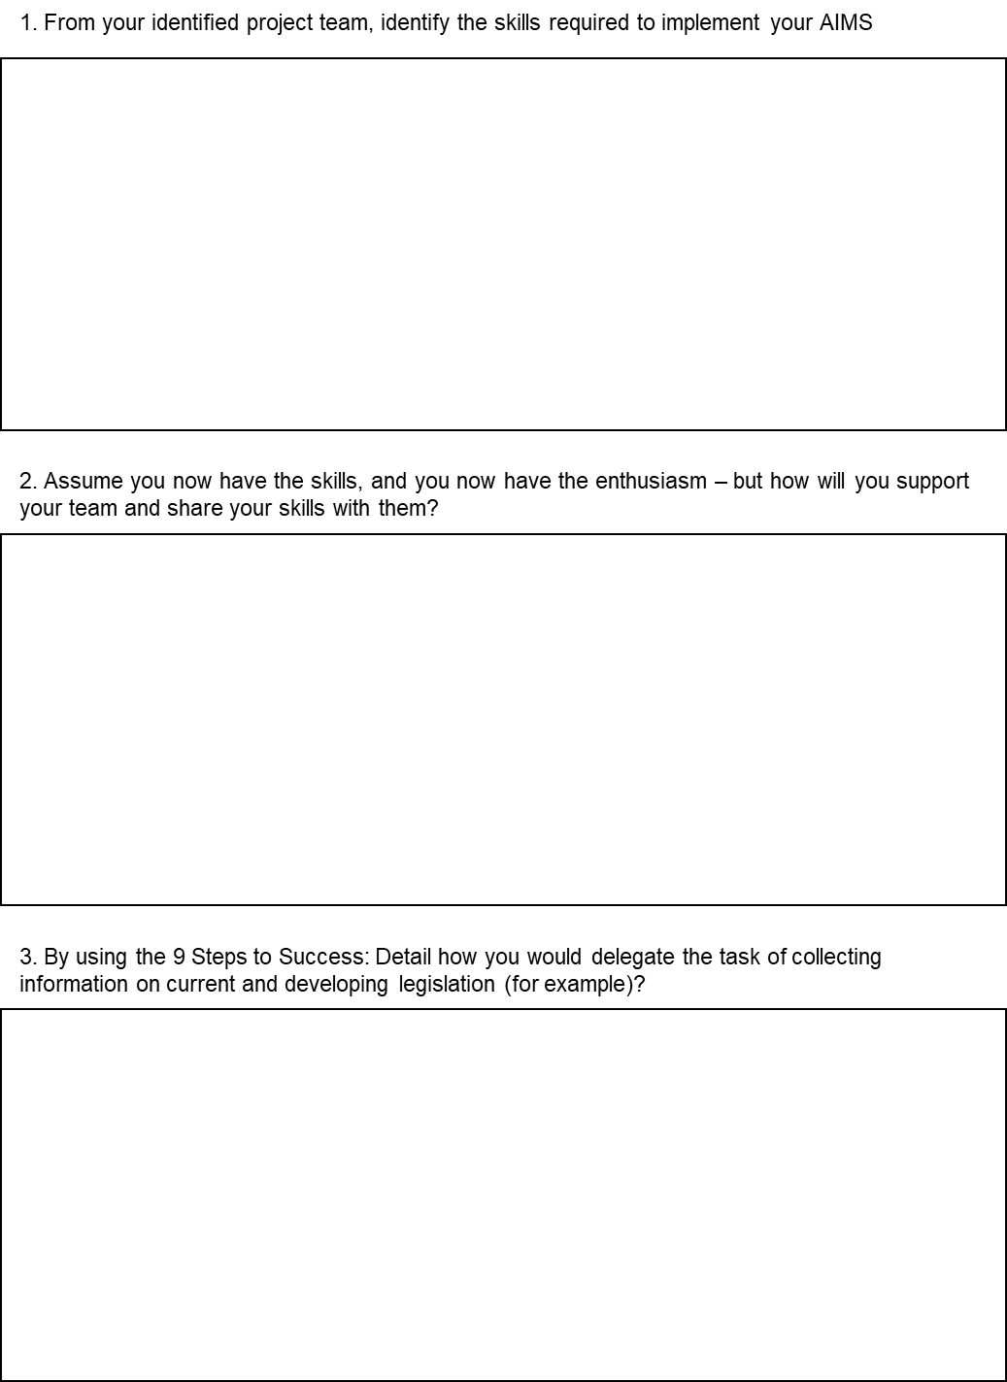

Activity 31: Motivation
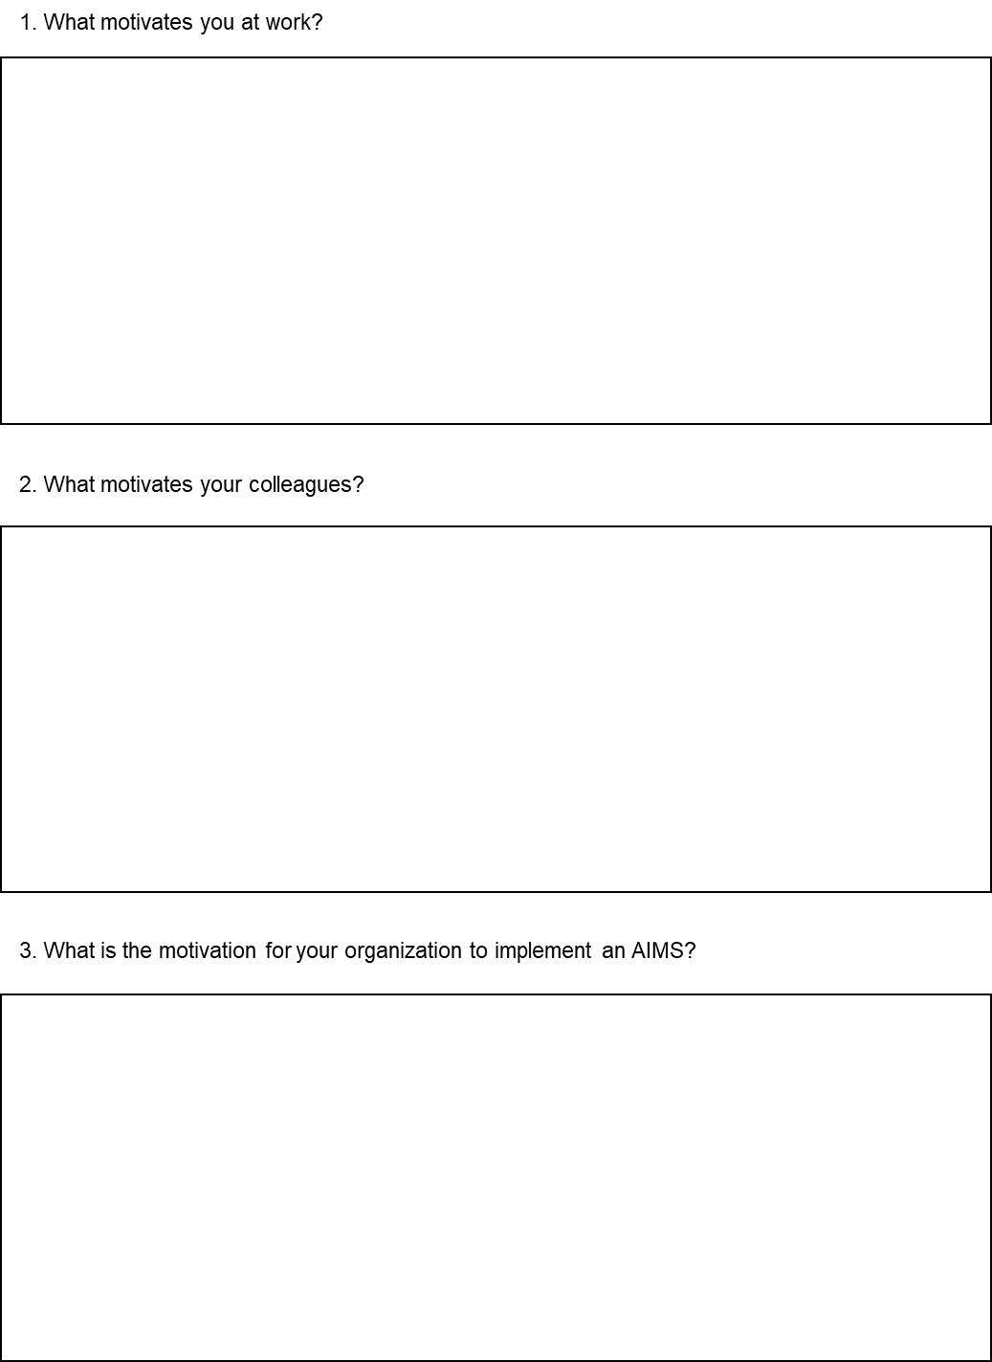

Activity 32: Specimen exam paper

